Chapter 14
Inventory Models

Learning Objectives

1. Learn where inventory costs occur and why it is important for managers to make good inventory policy decisions.

2. Learn the economic order quantity (EOQ) model.

3. Know how to develop total cost models for specific inventory systems.

4. Be able to use the total cost model to make how-much-to-order and when-to-order decisions.

5. Extend the basic approach of the EOQ model to inventory systems involving production lot size, planned shortages, and quantity discounts.

6. Be able to make inventory decisions for single-period inventory models.

7. Know how to make order quantity and reorder point decisions when demand must be described by a probability distribution.

8. Learn about lead time demand distributions and how they can be used to meet acceptable service levels.

9. Be able to develop order quantity decisions for periodic review inventory systems.

10. Understand the following terms:

inventory holding costs backorder
cost of capital quantity discounts
ordering costs goodwill costs
economic order quantity (EOQ) probabilistic demand
constant demand rate lead time demand distribution
reorder point service level
lead time single-period inventory model
lead time demand periodic review
cycle time
safety stock

Solutions:

1. a. 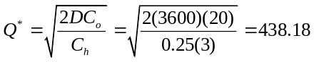

b. 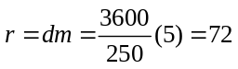

c. 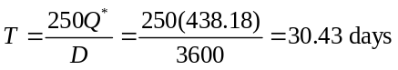

d. 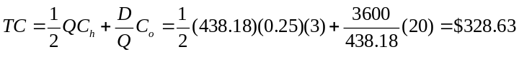

2. Annual Holding Cost

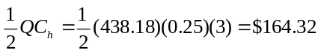

Annual Ordering Cost

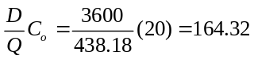

Total Cost = $328.64.

3. 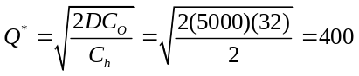
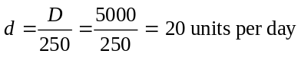

a. r = dm = 20(5) = 100

Since r ≤ Q*, both inventory position and inventory on hand equal 100.

b. r = dm = 20(15) = 300

Since r ≤ Q*, both inventory position and inventory on hand equal 300.

c. r = dm = 20(25) = 500

Inventory position reorder point = 500. One order of Q* = 400 is outstanding. The on-hand inventory reorder point is 500 - 400 = 100.

d. r = dm = 20(45) = 900

Inventory position reorder point = 900. Two orders of Q* = 400 are outstanding. The on-hand inventory reorder point is 900 - 2(400) = 100.

4. a. 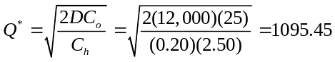

b. 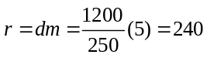

c. 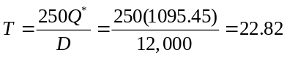

d. Holding 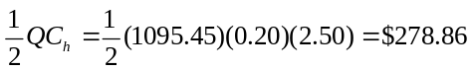
Ordering 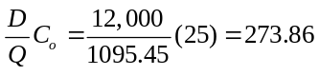

Total Cost = $547.72

5. a. 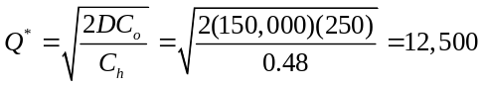

b. 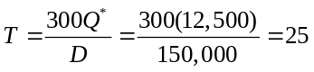days

300 days/25 days = 12 orders per year

One order per month

c. Maximum inventory = Q* = 12,500

Metropolitan Bus Company does not need to expand its storage tanks.

d. 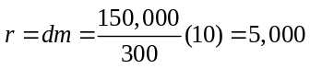gallons

6. a. = 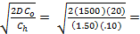632 pens, = 101 days

= 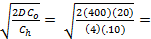200 pencils, = 120 days

Thus, the total cost is $94.87 + $80 = $174.87.

  - Setting the cycle times of pens and pencils equal:

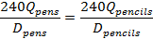

which implies .

The total cost (for both pens and pencils) is:

Substituting , we obtain

Combining like terms:

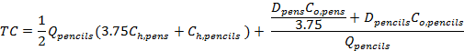

Solving for by observing that this total cost equation is the same as
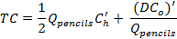
where and .

Thus,
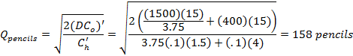

These quantities are ordered every T = (240)(593)/1500 = (240)(158)/400 = 95 days. The total cost (for both pens and pencils) is:

Thus, the consolidate shipments result in annual savings of $174.87 - $151.99 = $22.88.

7. 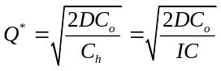 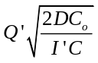

Where 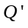 is the revised order quantity for the new carrying charge . Thus

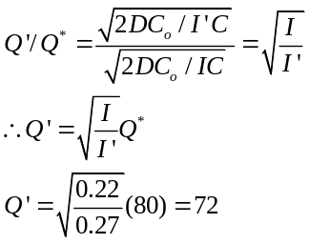

8. Annual Demand D = (5/month)(12 months) = 60

Ordering Cost = Fixed Cost per class = $22,000

Holding Cost = ($1,600/month)(12 months) = $19,200 per year for one driver

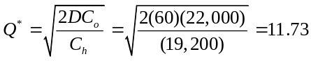

Use 12 as the class size.

D/Q* = 60/12 = 5 classes per year

Driver holding cost =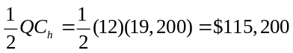

Class holding cost =

Total cost = $225,200

9. a. 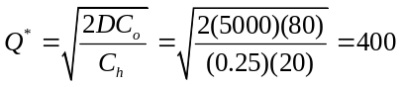
b. 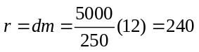

c. 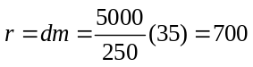

d. Since r = 700 and Q* = 400, one order will be outstanding when the reorder point is reached. Thus the inventory on hand at the time of reorder will be 700 - 400 = 300.

10. This is a production lot size model. However, the operation is only six months rather than a full year. The basis for analysis may be for periods of one month, 6 months, or a full year. The inventory policy will be the same. In the following analysis we use a monthly basis.

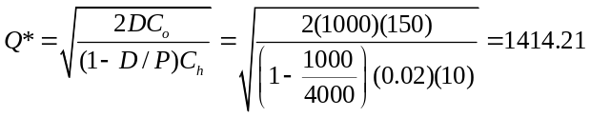

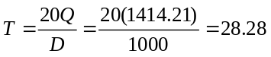days

Production run length = 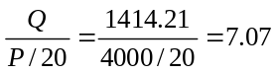days

11. 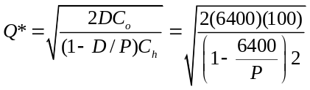

P = 8,000 | Q* = 1789
P = 10,000 | Q* = 1333
P = 32,000 | Q* = 894
P = 100,000 | Q* = 827

EOQ Model:

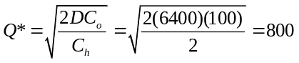

Production Lot Size Q* is always greater than the EOQ Q* with the same D, C0, and Ch values.

As the production rate P increases, the recommended Q* decreases, but always remains greater than the EOQ Q*.

12. a. 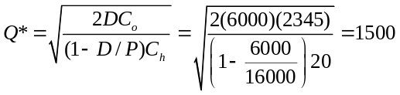

b. D/Q* = 6000/1500 = 4 production runs

12 months/4 = 3 month cycle time

c. Current total cost using Q = 500 is as follows:

Proposed Total Cost using Q* = 1500 is as follows:

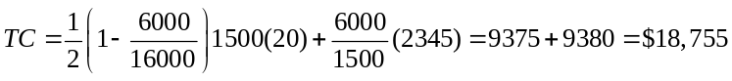

Change to Q* = 1500

Savings = $31,265 - $18,755 = $12,510

12,510/31,265 = 40% savings over current policy

13. a. 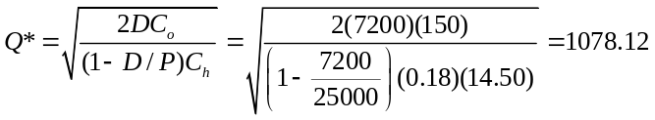

b. Number of production runs = D / Q* = 7200 / 1078.12 = 6.68

c. 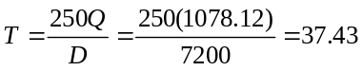days

d. Production run length = 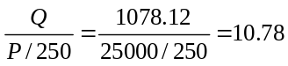days

e. Maximum Inventory

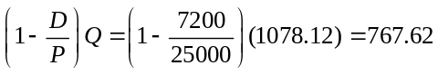

f. Holding Cost

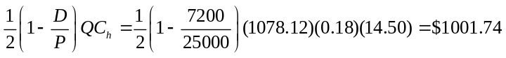

Ordering cost 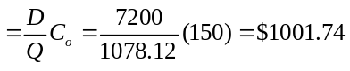

Total Cost = $2,003.48

g. 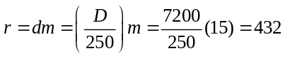

14. C = current cost per unit

C ' = 1.23 C new cost per unit
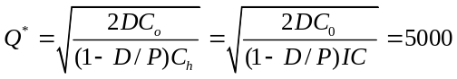

Let Q' = new optimal production lot size

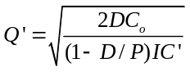

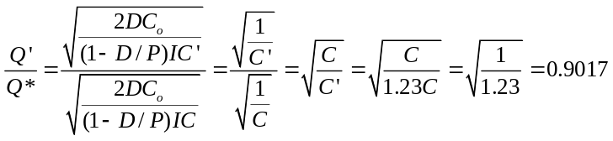

Q' = 0.9017(Q*) = 0.9017(5000) = 4509

15. a. 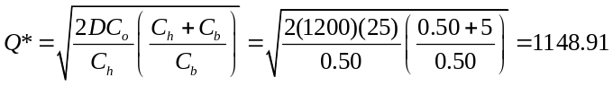

b. 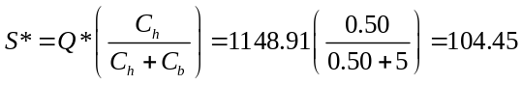

c. Max inventory = Q* - S* = 1044.46

d. 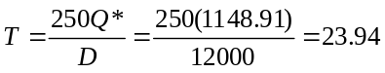

e. Holding: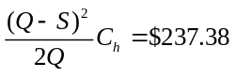

Ordering: 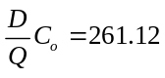

Backorder: 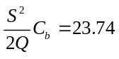

Total Cost: $522.24

The total cost for the EOQ model in problem 4 was $547.72. Allowing backorders reduces the total cost.

16. 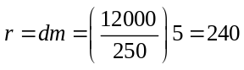

With backorder allowed the reorder point should be revised to

r = dm - S = 240 - 104.45 = 135.55

The reorder point will be smaller when backorders are allowed.

17. EOQ Model

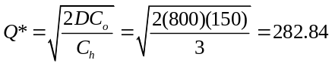

Total Cost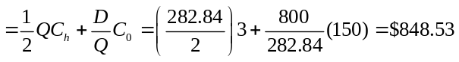

Planned Shortage Model

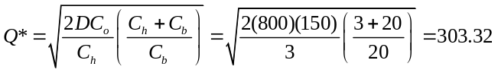

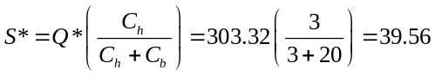

Total Cost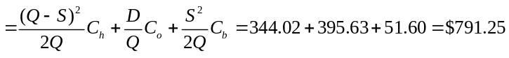

Cost Reduction with Backorders allowed

$848.53 - 791.25 = $57.28 (6.75%)

Both constraints are satisfied:

1. S / Q = 39.56 / 303.32 = 0.13

Only 13% of units will be backordered.

2. Length of backorder period = S / d = 39.56 / (800/250) = 12.4 days

18. Reorder points:

EOQ Model: 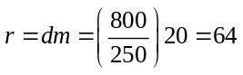

Backorder Model: r = dm - S = 24.44

19. a. 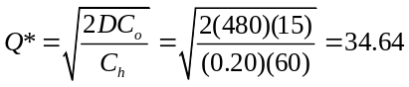

Total Cost: 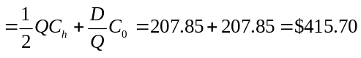

b. 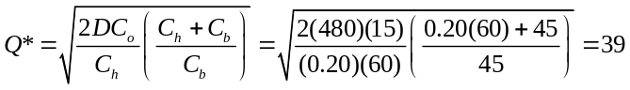

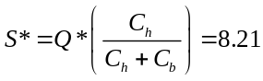

Total Cost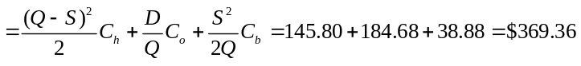

c. Length of backorder period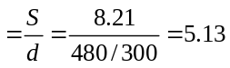days

d. Backorder case since the maximum wait is only 5.13 days and the cost savings is

$415.70 - 369.36 = $46.34 (11.1%)

e. EOQ: 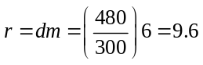

Backorder: r = dm - S = 1.39

20. 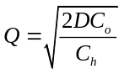

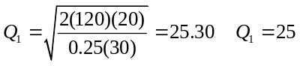

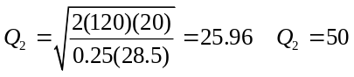to obtain 5% discount

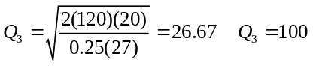to obtain 10% discount

Category | Unit Cost | Order  Quantity | Holding  Cost | Order Cost | Purchase  Cost | Total  Cost
1 | 30.00 | 25 | 93.75 | 96 | 3600 | $3,789.75
2 | 28.50 | 50 | 178.13 | 48 | 3420 | $3,646.13
3 | 27.00 | 100 | 337.50 | 24 | 3240 | $3,601.50

Q = 100 to obtain the lowest total cost.

The 10% discount is worthwhile.

21.

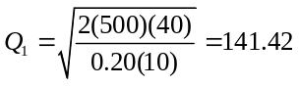

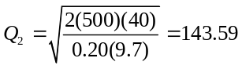

Since Q1 is over its limit of 99 units, Q1 cannot be optimal (see problem 23). Use Q2 = 143.59 as the optimal order quantity.

Total Cost: 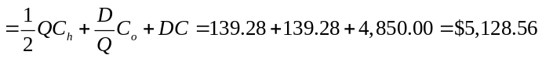
22. D = 4(500) = 2,000 per year

Co = $30

I = 0.20

C = $28

Annual cost of current policy: (Q = 500 and C = $28)

TC = 1/2(Q)(Ch) + (D/Q)Co + DC
= 1/2(500)(0.2)(28) + (2000/500)(30) + 2000(28)
= 1400 + 120 + 56,000 = 57,520

Evaluation of Quantity Discounts

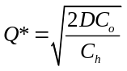

Order Quantity | Ch | Q* | Q to obtain  Discount | TC
0-99 | (0.20)(36) = 7.20 | 129 | * | —
100-199 | (0.20)(32) = 6.40 | 137 | 137 | 64,876
200-299 | (0.20)(30) = 6.00 | 141 | 200 | 60,900
300 or more | (0.20)(28) = 5.60 | 146 | 300 | 57,040

*Cannot be optimal since Q* > 99.

Reduce Q to 300 pairs/order. Annual savings is $480; note that shoes will still be purchased at the lowest possible cost ($28/pair).

23. 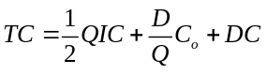

At a specific Q (and given I, D, and C0), since C of category 2 is less than C of category 1, the TC for 2 is less than TC for 1.

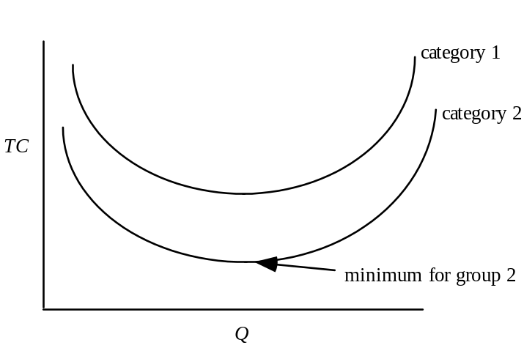

Thus, if the minimum cost solution for category 2 is feasible, there is no need to search category 1. From the graph we can see that all TC values of category 1 exceed the minimum cost solution of category 2.

24. a. Cost of overestimation, c_{o} = $9
Cost of underestimation, c_{u} = $10 - $9 -$0.50 = $0.50

P( demand ≤ Q*) =

From the normal table, a cumulative probability of 0.0526 corresponds to z = -1.62
Thus,
Q* = µ - 1.62σ = 9000 – (1.62)(400) = 8352 magazines.
b. Cost of overestimation, c_{o} = $9 - $8 = $1
Cost of underestimation, c_{u} = $10 - $9 -$0.50 = $0.50

P( demand ≤ Q*) =

From the normal table, a cumulative probability of 0.3333 corresponds to z = -0.43
Thus,
Q* = µ - 0.43σ = 9000 – (0.43)(400) = 8828 magazines.

25. a. c_{o} = 80 - 50 = 30

c_{u} = 125 - 80 = 45

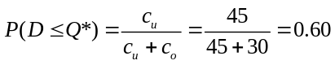

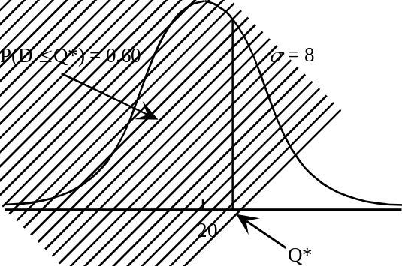
For the cumulative standard normal probability 0.60, z = 0.25

Q* = 20 + 0.25(8) = 22

b. P(Sell All) = P(D ≥ Q*) = 1 - 0.60 = 0.40

26. a. c_{o} = $150

b. The city would have liked to have planned for more additional officers at the $150 per officer rate. However, overtime at $240 per officer will have to be used.

c_{u} = $240 - $150 = $90

c. 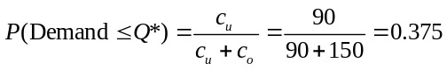

For the cumulative standard normal probability 0.375, z = -0.32

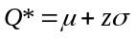= 50 - 0.32(10) = 46.8

Recommend 47 additional officers

d. P(Overtime) = 1 - 0.375 = 0.625

27. a. c_{o} = 1.19 - 1.00 = 0.19

c_{u} = 1.65 - 1.19 = 0.46

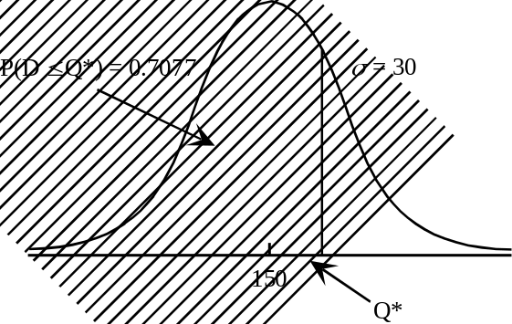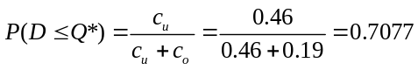

For the cumulative standard normal probability 0.7077, z = 0.55

Q* = 150 + 0.55(30) = 166.5

b. P(Stockout) = P(D ≥ Q*) = 1 - 0.7077 = 0.2923

c. c_{o} = 1.19 - 0.25 = 0.94

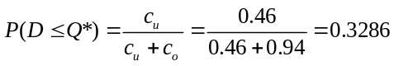

For the cumulative standard normal probability 0.3286, z = -0.45

Q* = 150 - 0.45(30) = 136.50

The higher rebate increases the quantity that the supermarket should order.

28. a. c_{o} = 8 - 5 = 3

c_{u} = 10 - 8 = 2

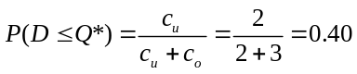

Q* is 40% of way between 700 and 800

Q* = 200 + 0.40(600) = 440

b. P(stockout) = P(D ≥ Q*) = 1 - 0.40 = 0.60

c. P(D ≤ Q*) = 0.85 P(Stockout) = 0.15

Q* = 200 + 0.85(600) = 710

d. Let g = goodwill cost

c_{u} = lost profit + goodwill cost = (10 - 8) + g = 2 + g

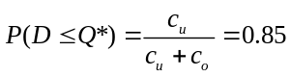

Solve for c_{u} = 17
c_{u} = 2 + g = 17
g = 15

29. a. r = dm = (200/250)15 = 12

b. D / Q = 200 / 25 = 8 orders / year

The limit of 1 stockout per year means that

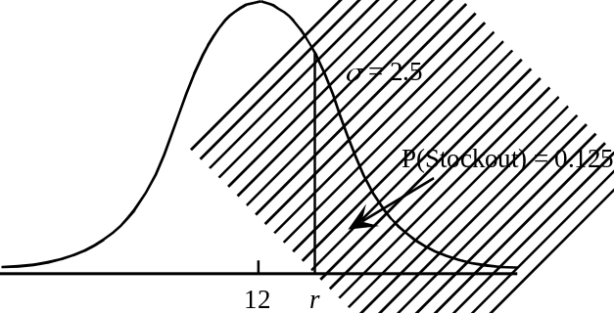 P(Stockout/cycle) = 1/8 = 0.125

P(No Stockout/cycle) = 1 – 0.125 = 0 .875

For the cumulative standard normal probability 0.875, z = 1.15

Thus, 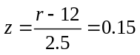
or

r = 12 + 1.15(2.5) = 14.875 Use 15

c. Safety Stock = 3 units

Added Cost = 3($5) = $15/year

30. a. Q* = 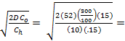55.86 ≈ 56 boxes.
b. r = µ + zσ = 300 + (2.33)(75) = 474.75 ≈ 475 cups.

31. a. 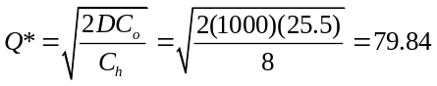

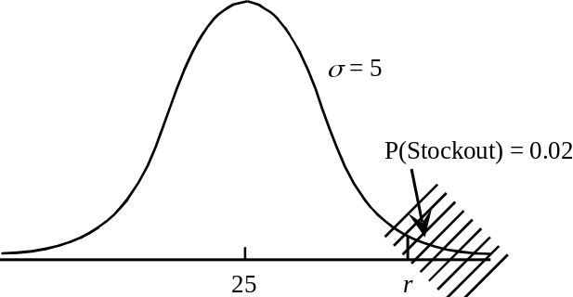 b.

P(No Stockout/cycle) = 1 – 0.02 = 0 .98

For the cumulative standard normal probability 0.98, z = 2.05

Thus, 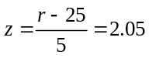
or

r = 25 + 2.05(5) = 35.3 Use 35

Safety Stock = 35 - 25 = 10

Safety Stock Cost = (10)($8) = $80/year

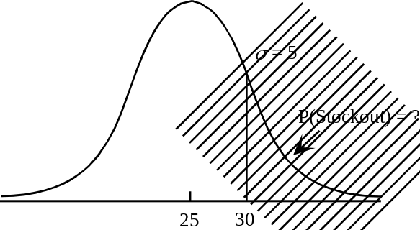 c.
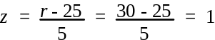

The cumulative standard normal probability for z = 1 is 0.8413.

Thus, P(Stockout/cycle) =1.0.8413 = 0.1587

Number of Stockouts/year = 0.1587 (Number of Orders) = 0.1587 D/Q = 2

32. a. 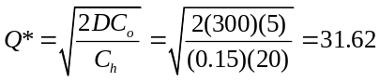

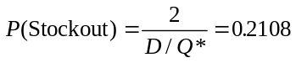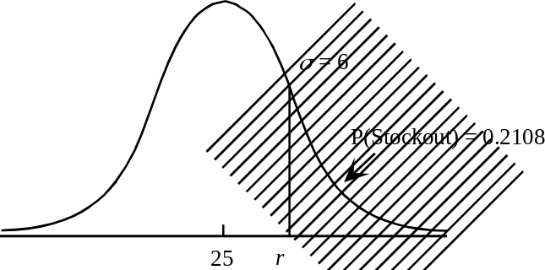 b. D / Q* = 9.49 orders per year

P(No Stockout) = 1 – 0.2108 = 0.7892

For the cumulative standard normal probability 0.7892, z = 0.80

Thus, 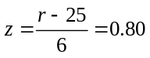
or

r = 15 + 0.80(6) = 19.8 Use 20

c. Safety Stock = 20 - 15 = 5

Safety Stock Cost =5(0.15)(20) = $15

33. a. 1/52 = 0.0192

b. P(No Stockout) = 1 – 0.0192 = 0.9808

For the cumulative standard normal probability 0.9808, z = 2.07

Thus, 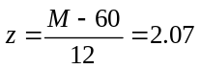
or

M = µ + zσ = 60 + 2.07(12) = 85

c. M = 35 + (0.9808)(85-35) = 84

34. a. P(Stockout) = 0.01 z = 2.33

P(No Stockout) = 1 – 0.01 = 0.99

For the cumulative standard normal probability 0.99, z = 2.33

Thus, 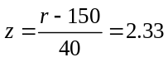
or

r = µ + zσ = 150 + 2.33(40) = 243

b. Safety Stock = 243 - 150 = 93 units
Annual Cost = 93(0.20)(2.95) = $54.87

c. z = 2.33

M = µ + zσ = 450 + 2.33(70) = 613 units

d. Safety Stock = 613 - 450 = 163 units
Annual Cost = 163(0.20)(2.95) = $96.17

e. The periodic review model is more expensive ($96.17 - $54.87) = $41.30 per year. However, this added cost may be worth the advantage of coordinating orders for multi products. Go with the periodic review system.

f. Unit Cost = $295 Annual Difference = $4,130
Use continuous review for the more expensive items.

35. a. 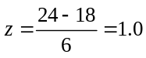
The cumulative standard normal probability for z = 1.0 is 0.8413.

P(Stockout) = 1.0000 - 0.8413 = 0.1587

b. P(Stockout) = 0.025

P(No Stockout) = 1 – 0.025 = 0.975

For the cumulative standard normal probability 0.975, z = 1.96

Thus, 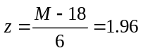
or

M = µ + zσ = 18 + 1.96(6) = 29.76

Use M = 30.

The manager should have ordered Q = 30 - 8 = 22 units.

36. a. µ = Week 1 demand + Week 2 demand + Lead Time demand
= 16 + 16 + 8 = 40

b. σ2 = Var (Week 1) + Var (Week 2) + Var (Lead Time)
= 25 + 25 + 12.25 = 62.25

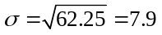

c. 26 orders per year

P(Stockout) = 1/26 = 0.0385 per replenishment

P(No Stockout) = 1 – 0.0385 = 0.9615

For the cumulative standard normal probability 0.9615, z = 1.77

Thus, 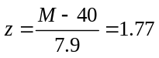
or

M = µ + zσ = 40 + 1.77(7.9) = 54

d. 54 - 18 = 36

